# 任务单08

班级： 姓名： 学号：

1. 编写程序Car类，私有属性有车重、颜色、档位、车速、有无gps，公有行为有挂档，档位N与车速speed之间的关系为speed = N * 30，公有重载方式实现车辆重新喷色、加装gps，打印输出车速、车重、颜色、有无gps.

程序代码：

**public** **class** Car {

**private** **int** weight;

**private** String color;

**private** **int** N;

**private** **int** speed;

**private** **boolean** gps;

**public** **void** change(String color){

**this**.color = color;

}

**public** **void** change(String color, **boolean** gps){

**this**.gps = gps;

}

**public** **void** print_Info(){

String isgps = gps == **true** ? "有":"无";

System.***out***.println("车速："+speed+",车重："+weight+",颜色："+color+"，"+isgps+"gps");

}

**public** **int** getWeight() {

**return** weight;

}

**public** **void** setWeight(**int** weight) {

**this**.weight = weight;

}

**public** String getColor() {

**return** color;

}

**public** **void** setColor(String color) {

**this**.color = color;

}

**public** **int** getN() {

**return** N;

}

**public** **void** setN(**int** n) {

N = n;

}

**public** **int** getSpeed() {

**return** **this**.speed = N * 30;

}

**public** **boolean** isGps() {

**return** gps;

}

**public** **void** setGps(**boolean** gps) {

**this**.gps = gps;

}

**public** **static** **void** main(String[] args) {

Car ca = **new** Car();

ca.setColor("黄色");

ca.setGps(**true**);

ca.setN(20);

ca.setWeight(30);

ca.print_Info();

ca.change("绿色");

ca.print_Info();

ca.change("金色", **false**);

ca.print_Info();

}

}

运行结果：

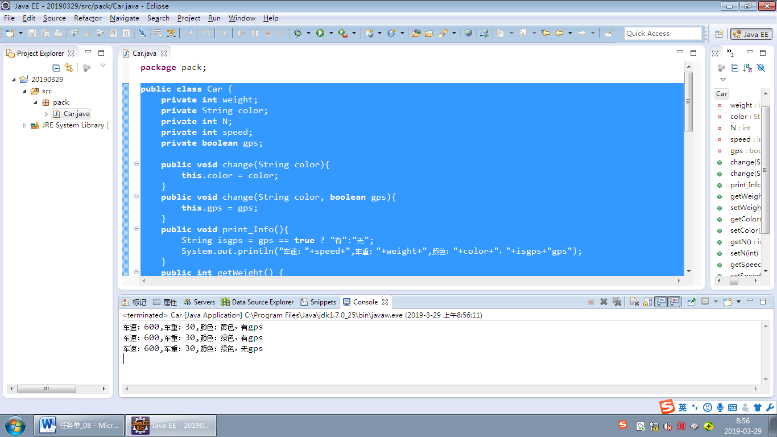

2．设计一个Worker类，其成员变量有身份证号、姓名、性别、年龄、入职时间、工资/月、奖金/月、加班费/月、电话费/月、生活费/月、交通费/月、房租/月。

用构造方法进行初始化（至少要写三个构造方法）。

其他成员方法：输出工人信息的方法（当某个属性没有赋初值时，输出“未知”），计算总收入办法，计算总支出办法。

程序代码：

**public** **class** Worker {

String idcard;

String name;

**char** sex;

**int** age;

String jointime;

**float** salary;

**float** paris;

**float** continuework;

**float** phonecoast;

**float** live;

**float** transport;

**float** zufang;

**public** **void** Init() {

**this**.idcard = "未知";

**this**.name = "未知";

**this**.sex = 'n';

**this**.age = 0;

**this**.jointime = "未知";

**this**.salary = **this**.paris =

**this**.continuework = **this**.phonecoast =

**this**.transport = **this**.live = **this**.zufang = -1;

}

**public** Worker() {

Init();

}

**public** Worker(String idcard, String name, **char** sex, **int** age, String jointime) {

Init();

**this**.idcard = idcard;

**this**.name = name;

**this**.sex = sex;

**this**.age = age;

**this**.jointime = jointime;

}

**public** Worker(**float** salary, **float** paris, **float** continuework,

**float** phonecoast, **float** transport, **float** live, **float** zufang) {

Init();

**this**.salary = salary;

**this**.paris = paris;

**this**.continuework = continuework;

**this**.phonecoast = phonecoast;

**this**.transport = transport;

**this**.live = live;

**this**.zufang = zufang;

}

**public** Worker(String idcard, String name, **char** sex, **int** age, String jointime,**float** salary, **float** paris, **float** continuework,

**float** phonecoast, **float** transport, **float** live, **float** zufang) {

**this**.idcard = idcard;

**this**.name = name;

**this**.sex = sex;

**this**.age = age;

**this**.jointime = jointime;

**this**.salary = salary;

**this**.paris = paris;

**this**.continuework = continuework;

**this**.phonecoast = phonecoast;

**this**.transport = transport;

**this**.live = live;

**this**.zufang = zufang;

}

**public** **void** print_Info() {

String not = "未知";

String st = "身份证：" + idcard + ",名字："+ name + "，性别："

+ (sex == 'n' ? not : sex) + ",年龄：" + (age == 0 ? not : age)

+ ",入职时间：" + jointime + ",薪水："

+ (salary == -1 ? not : salary) + ",奖金："

+ (paris == -1 ? not : paris) + ",加班费："

+ (continuework == -1 ? not : continuework) + ",电话费："

+ (phonecoast == -1 ? not : phonecoast) + ",生活费："

+ (live == -1 ? not : live) + ",交通费："

+ (transport == -1 ? not : transport) + ",房租费："

+ (zufang == -1 ? not : zufang);

System.***out***.println(st);

}

**public** **float** allpay() {

**return** phonecoast + live + transport + zufang;

}

**public** **float** allshouru() {

**return** (salary + paris + continuework) - allpay();

}

**public** **static** **void** main(String[] args) {

Worker wo = **new** Worker();

wo.print_Info();

wo = **new** Worker("360732", "张三", '男', 19, "2019年3月29日");

wo.print_Info();

wo = **new** Worker("360732", "张三", '男', 19, "2019年3月29日", 3000, 1500, 300, 50, 200, 1000, 800);

wo.print_Info();

System.***out***.println("总支出:" + wo.allpay());

System.***out***.println("总收入：" + wo.allshouru());

}

}

运行结果：

